AI Assisted Problem Solving Using Python

Name: Mettu Nandini
MTech – 1st Year
HTNO: 2505B04208

Lab 18 – Code Translation: Converting Between Programming Languages

Task 1: Translate a Simple Program (Python → JavaScript)
- Instructions:
  - Write a Python function print_numbers() that prints the first 10 natural numbers using a loop.
  - Translate the function into JavaScript as a reusable function printNumbers().
  - Call the function in both languages to display results.
- Expected Output:
- 1
- 2
- 3
- ...10

Python code:
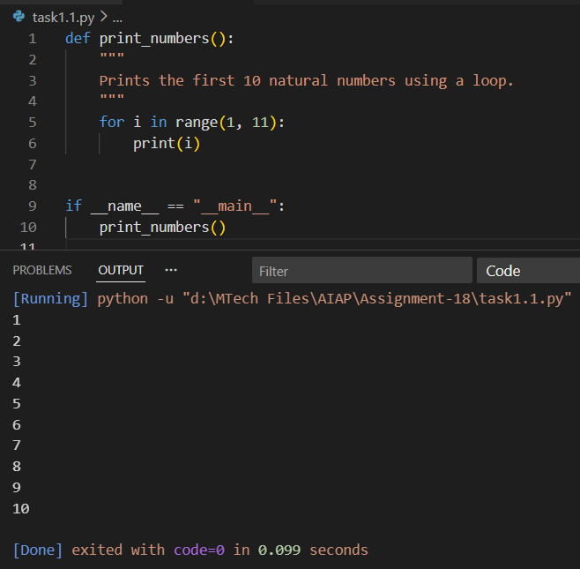
Javascript code:
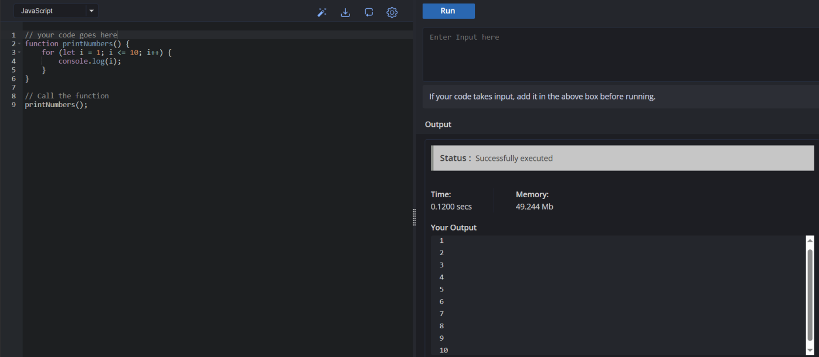
Task 2: Convert Conditional Statements (Java → Python)
- Instructions:
  - Write a Java method checkNumber(int num) that checks if a number is positive, negative, or zero.
  - Translate the method into a Python function check_number(num).
  - Call the function/method with different inputs and compare outputs.
- Expected Output:
  - Input: -5 → Output: The number is negative
  - Input: 0 → Output: The number is zero
  - Input: 7 → Output: The number is positive

Java code:
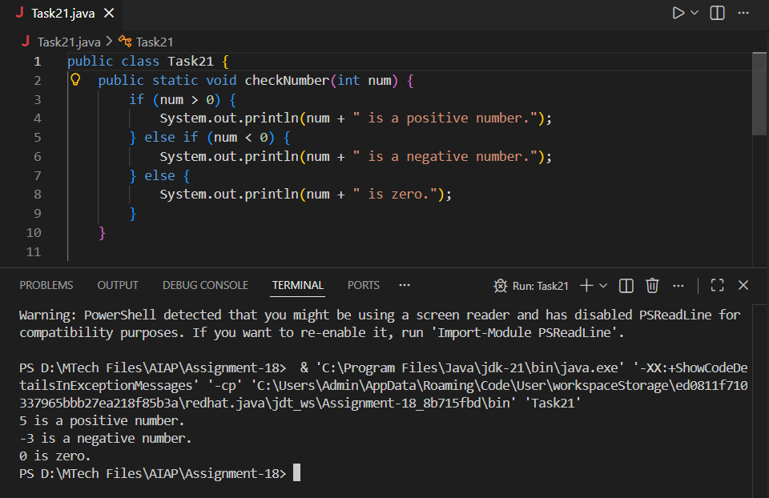

Python code:
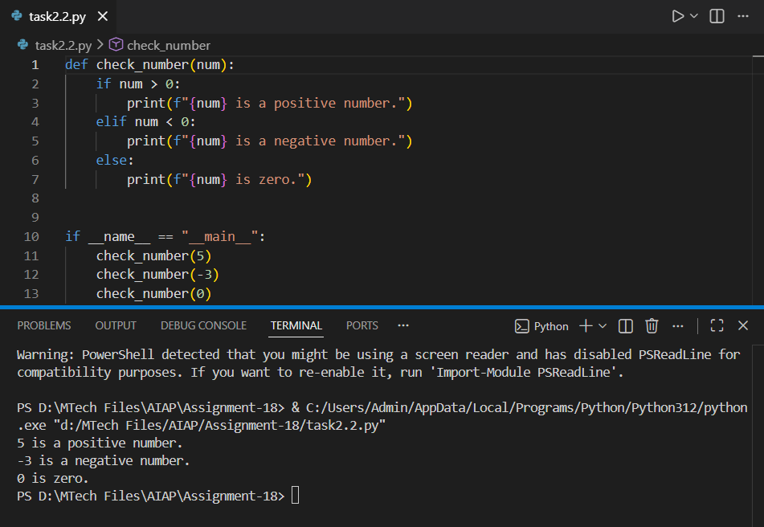
Task 3: Translate Recursive Function (Python → C++)
- Instructions:
  - Write a Python function factorial(n) that calculates factorial of a number using recursion.
  - Translate the same into a C++ function int factorial(int n).
  - Call the function in both languages with inputs 5 and 0.
- Expected Output:
  - Input: 5 → Output: Factorial = 120
  - Input: 0 → Output: Factorial = 1
Python code:
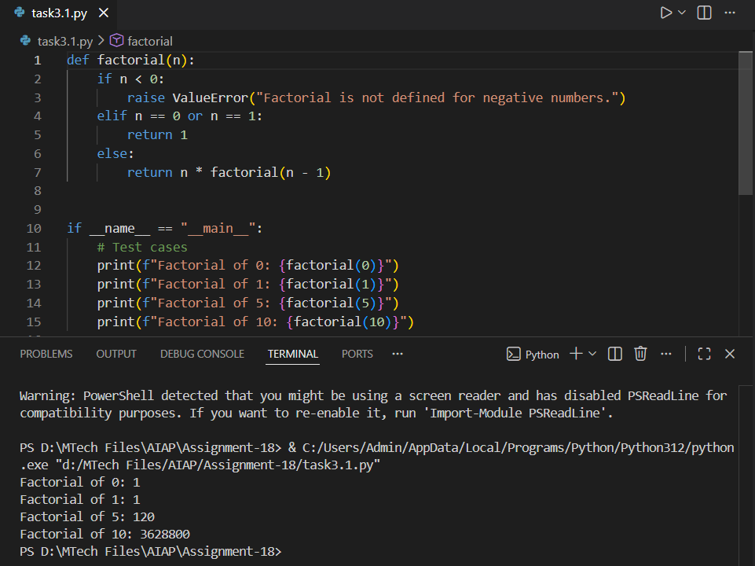
C++ code:
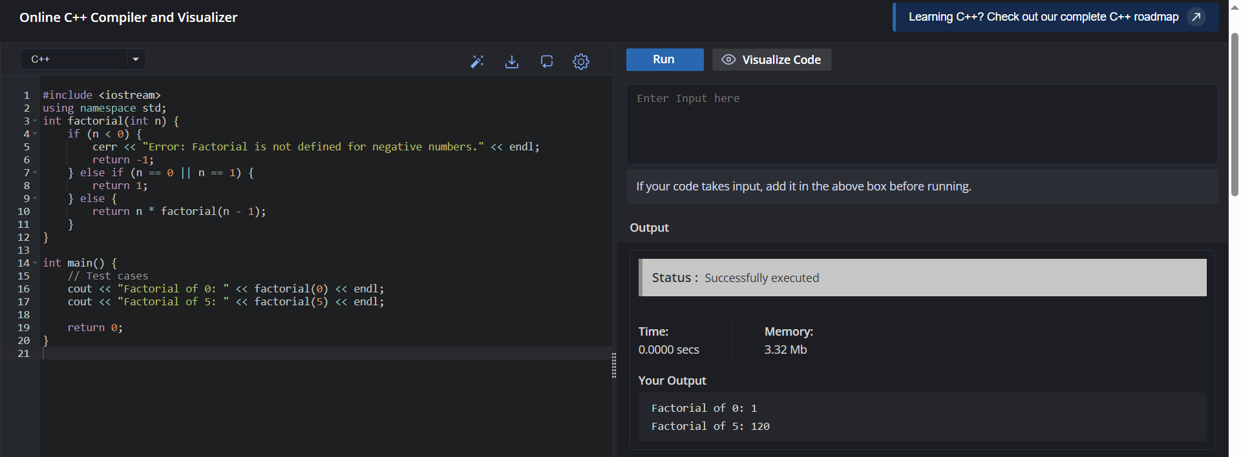
Task 4: Data Structures with Functions (JavaScript → Python)
- Instructions:
  - Write a JavaScript function printStudents(students) that takes an array of student names and prints each name.
  - Translate it into a Python function print_students(students) using a list.
  - Test both functions with sample student names.
- Expected Output:
- Student List:
- Alice
- Bob
- Charlie

Javascript code:
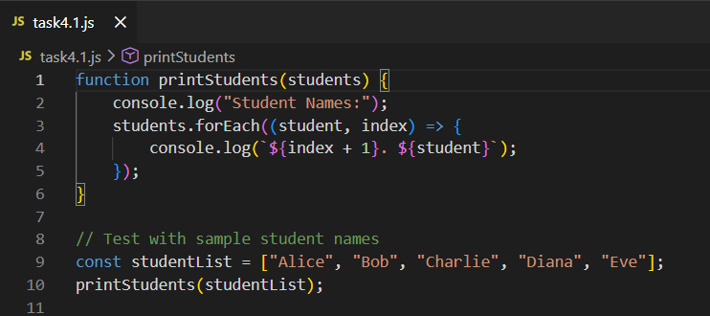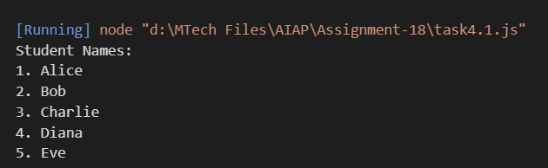
Python code:
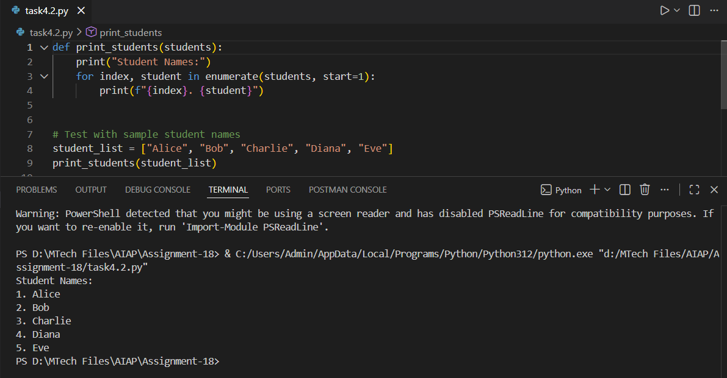

Task 5: Class & Object Translation (Python → Java)
- Instructions:
  - Write a Python class Car with attributes: brand, model, year.
  - Add a methoddisplay_details() that prints car details.
  - Translate the same into a Java class Car with attributes and a methoddisplayDetails().
  - Create an object in both languages and call the method.
- Expected Output:
- Car Details:
- Brand: Toyota
- Model: Corolla
Year: 2020
Python code:
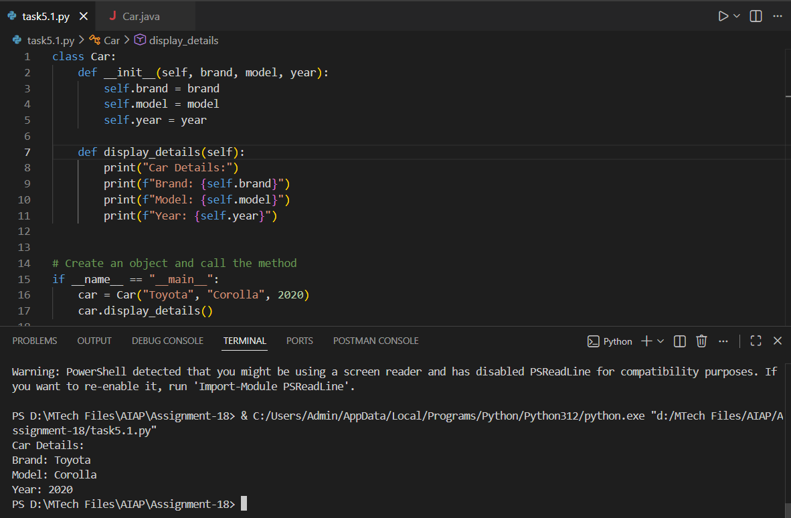
Java code:
